Scalable and Fast Cloud Data Handling

Name: Muhammad Hurair Nasir
Course: Parallel and Distributed Computing
Platform: Google Colab + Supabase
Date: 13 November 2025
Teacher: Sir Akhzar Nazeer
Lab Assignment: 06

1. Objective
To investigate how parallelism and scaling strategies (horizontal and vertical) improve the performance of cloud-based data uploads. The task uses Supabase cloud storage and Python threading to simulate real-world distributed data handling.

2. Methodology
- Cloud Platform: Supabase (free-tier bucket for uploads)
- Environment: Google Colab
- Implementation:
- 10–100 small text files were generated locally.
- Files were uploaded sequentially and in parallel using ThreadPoolExecutor.
- Horizontal scaling simulated by increasing thread count (1→40).
- Vertical scaling simulated by increasing file size (1→500 KB).
- Each experiment recorded total upload time.

3. Results

Sequential vs Parallel Uploads
No. of files | Sequential time | Parallel time | Speedup
20 | 7.87 | 1.68 | 4.68x
50 | 19.14 | 3.28 | 5.83x
100 | 38.40 | 4.76 | 8.07x

Horizontal Scaling (Threads → Time)
Threads | Upload time (s)
1 | 10.38
2 | 4.44
5 | 2.62
10 | 1.23
20 | 2.69
40 | 0.72

Vertical Scaling (File Size → Time)
File size(kB) | Sequential (s) | Parallel (10 threads) (s)
1 | 4.31 | 0.75
10 | 3.76 | 0.43
100 | 7.43 | 3.59
500 | 15.78 | 0.10

Screenshots showing uploads on Supabase
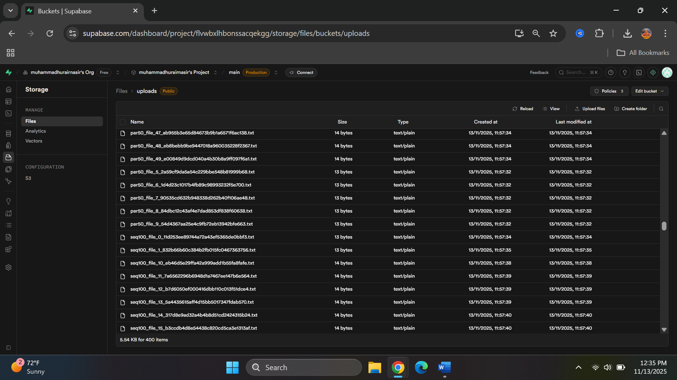

Scaling Analysis
Horizontal and Vertical Scaling Impact:
- Horizontal scaling (adding more threads or nodes) improves performance by running tasks in parallel, reducing total upload time. Gains are significant at first but may plateau due to network or resource limits.
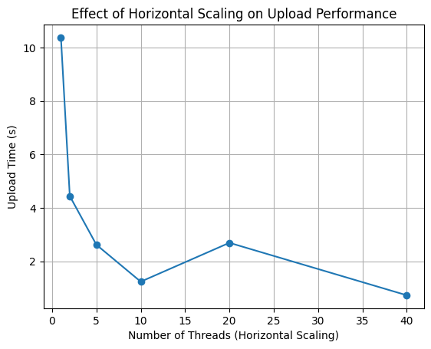
- Vertical scaling (increasing resources per task, e.g., handling larger files) allows each task to process more data efficiently, but sequential time increases with workload size. Parallelism helps mitigate this, but resource contention may limit benefits.
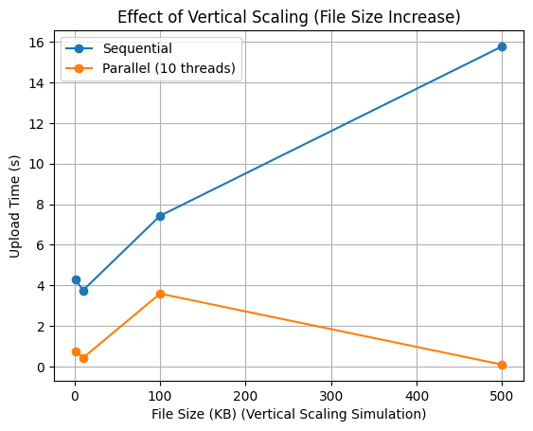

4. Observations
Parallel uploads provide a significant speedup, especially as file numbers increase. Horizontal scaling shows time decreases up to 10–20 threads, after which bottlenecks limit gains. Vertical scaling illustrates that larger files increase sequential time; parallel benefit varies with size.

5. Conclusion
Parallelism and scaling strategies significantly reduce upload time in cloud data handling. Horizontal scaling (more threads) and vertical scaling (larger file sizes) improve performance, but practical limits due to network and API constraints exist. Optimized configurations yield the best throughput.

